**MINOR-2 PROJECT**

**ENDSEM REPORT ON SHOPPING ASSISTANT**

SUBMITTED BY:

|  |  |  |  |
| --- | --- | --- | --- |
| **NAME** | **ROLL NO.** | **BRANCH** | **SAP ID** |
| MUDIT GARG | R171217036 | B.TECH-CSE DEVOPS | 500062539 |
| PARTH RAI | R171217042 | B.TECH-CSE DEVOPS | 500062220 |
| RACHIT CHAUHAN | R171217049 | B.TECH-CSE DEVOPS | 500060009 |
| CH SRI SRI VALLI | R171217058 | B.TECH-CSE DEVOPS | 500060228 |

**Under The Guidance of** Ms. NITIKA GOENKA Assistant Professor (SS) Department of Cybernetics



SCHOOL OF COMPUTER SCIENCE **UNIVERSITY OF PETROLEUM & ENERGY STUDIES** DEHRADUN (2019-20)

**APPROVED BY**

(Dr. MONIT KAPOOR) (Ms. NITIKA GOENKA)

DEPARTMENT HEAD PROJECT MENTOR

**TABLE OF CONTENTS PGNO.**

## Candidate’s Declaration 3

## Acknowledgement 4

Abstract 5

Introduction 5

Problem Statement 5

Literature 6

Objective 7

Methodology 7

System Requirement 7

Implementation 8

Output 9

Pert chart 11

References 12

## 

## 

## CANDIDATE’S DECLARATION

We hereby certify that the project work entitled “***Shopping Assistant***”in partial fulfillment the requirements for the award of the Degree of BACHELOR OF TECHNOLOGY in COMPUTER SCIENCE AND ENGINEERING with specialization in DevOps and submitted to the School of Computer Science, Department of Virtualization, University of Petroleum & Energy Studies, Dehradun, is an authentic record of my our work carried out during a period from **Jan-2020 to May-2020** under the supervision of **Ms.Nikita Goenka, Assistant Professor, Dept. of Cybernetics.**

This is to certify that the above statement made by the candidate is correct to the best of my knowledge.

Date: 10/05/2020

Project Guide

## Ms. Nitika Geonka

**Dr. Monit Kapoor**

HOD – Cybernetics

School of Computer Science

University of Petroleum & Energy Studies Dehradun – 248001 (Uttarakhand)

# 

# 

# 

# 

# 

# ACKNOWLEDGEMENT

We wish to express our deep gratitude to our guide **Ms. Nitika Geonka**, for all the advice, encouragement and constant support he has given us throughout our project work. This work would not have been possible without her support and valuable suggestions.

We sincerely thank to our respected Program Head of the Department,

**Dr. Monit Kapoor**, for his great support in doing our project.

**ABSTRACT**

Technology is improving day by day, it is comforting us. Keeping aside the pros and cons of rapid technology, it is making our day-to-day chores easier. With a click, we can do so many things on our smartphone. E-commerce shopping sites have become a boon to the people who are dealing with their busy lifestyles. We can go through various products, as there are plenty of options available out there. As there are a large number of customers who are accessing the shopping sites, doubts do occur regarding- exchange, delivery, return, etc. So to bring these all doubts of the customers on one platform, we are introducing a chatbot called the “Shopping Assistant”. The “Shopping Assistant” is used exclusively for the e-commerce shopping website, once the order is placed by the customer the Shopping Assistant comes into frame to help the customers if there are any doubts from the customer end regarding their order. We are integrating the “Shopping Assistant” to a website.

**INTRODUCTION**

ChatBot is a software application that performs automated tasks and various other activities that help customers to know about the products or any information in an efficient manner. They come under the category of bots that live on various chat platforms. It is a program that communicates with the user or you. The chatbot can talk to you through different platforms or channels such as: Facebook , Messenger, Shopping site etc.

**PROBLEM STATEMENT**

The main motto behind designing the “Shopping Assistant”(chat-bot) is to provide a single platform for all the queries from the customers. As we look into some websites, there are various buttons, options are available for any information/doubts from the customers end after ordering the product.

The “Shopping Assistant” increases the feasibility of the customer, and provides a better platform to clear their doubts and provide information. Since there is a heavy demand and supply for E-commerce shopping websites, these types of applications convert the general e-commerce websites to conversational commerce. The “Shopping Assistant” can be integrated into a website also.

A chat-bot is generally a computer program that simulates human conversation through voice commands or text chats or both. A chatbot is a short form of chatter-bot. “Shopping Assistant” is a textual chat-bot.

**LITERATURE**

There are various kinds of chat-bots that are used for different purposes in websites. Just like “The Shopping Assistant” there are also many such chat-bots available that provide assistance to the customers either by voice commands or by text. Chat-bots such as Kik Bot Shop, Sephora, Magic,eBay, H&M, are the chat-bots that provide the needed information requested by the customers, the information include many images/locations/text or all of them.

[1]H&M’s bot functions much like a personal shopping assistant. After asking a few questions regarding the user’s style preferences, sizes, and shopping tendencies, recommendations come in multiple-choice fashion.[2]Foundationally, it’s similar to the Sephora chat-bot, trying to discern your tastes in order to serve the best recommendations. However, it’s a bit too specific, asking shoppers to choose between items, rather than categories. The bot’s outfit builder serves your products at random.

[2]On Kik, Sephora’s bot opens up with an invitation to take a style quiz, which helps deliver the most relevant product recommendations. The questions were all multiple choice and none of the answers fit in the “I’m just here to have conversations with chat-bots for a story” category, so I answered them as if I were a real shopper. The chat-bot got to the bottom of what I was allegedly looking for, serving the product recommendations, complete with reviews, within seconds.

The bot has difficulty with variations in wording, though the answers nail the brand voice.

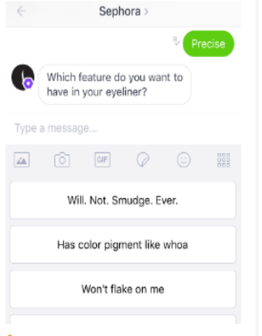

**OBJECTIVE**

The “SHOPPING ASSISTANT” chatbot, involves the process of solving the queries of customers regarding doubts, tracking details, refund, exchange, etc.

**METHODOLOGY**

Methodology is the rules that govern the system method; on the other hand it is a systematic procedure for the set of activities. Thus, from these definitions, methodology encompasses methods used within the system. Here, the Waterfall model under the Software Development Life Cycle (SDLC) is used.

In this methodology the development process is divided into several small processes or stages. After the completion of one process, it will move to another process automatically. Sometimes, going back to the previous stage is useful as some error goes on the current stage.

To create the chat-bot we are using Java AIML. AIML(Artificial Intelligence Markup Language) is an XML dialect for creating natural language software agents, it contains the basic rules which NLU(Natural Language Understanding) uses internally. Website is in progress for integrating with chat-bot.

**SYSTEM REQUIREMENTS (SOFTWARE/HARDWARE)**

**Hardware Interface:**

32 bits processor architecture supported by windows.

RAM requirement for proper functioning is 2 GB.

**Software Interface:**

This system is developed in Java programming language

**IMPLEMENTATION**

We have implemented chatbot with the help of AIML (Artificial Intelligence Markup Language).

AIML is an XML dialect for creating natural language software agents. It is considered as the heart of the engine. The more rules we add in AIML – the more intelligent our Chatbot will be.

The chatbot is created in two platforms -

1.Eclipse

2.Pandorabots

A website is also created called “Happie Shoppie”. It is an e-commerce website, for which we have created the shopping assistant.

**1.Eclipse**

We are using eclipse for development purposes,with the help of maven.Program AB is the reference implementation of the AIML 2.0 draft specification.It has the jar files included for the aiml. Program-ab is a zip file which contains all the libraries, jar files needed to develop a aiml based project.

A maven project is created.

We install jar(ab.jar) into the local maven repository(pom.xml) and then use it (program-ab distribution).

Create a folder where we can add all the libraries of the aiml from the downloaded zip file(program-ab).

In eclipse, we have to write java code to implement the aiml files. For the inputs and outputs of the chatbot, we need to add an “.aiml” file where all the expected questions from the customer and responses from our chatbot are designed. And the chatbot is displayed in the console.

**2.Pandorabots**

Pandorabots is a platform which provides web services for building and deploying chatbots. It helps to build the chatbot using “aiml”. Here the chatbot is created using aiml.There is a aiml code editor provided ,where we can do the aiml code for our shopping assistant.

The main reason to create the chatbot in this platform is , it provides API for the “aiml” code that we had done. The framework/outline for our aiml code is provided by the pandorabots.

**OUTPUT -**

**Eclipse**

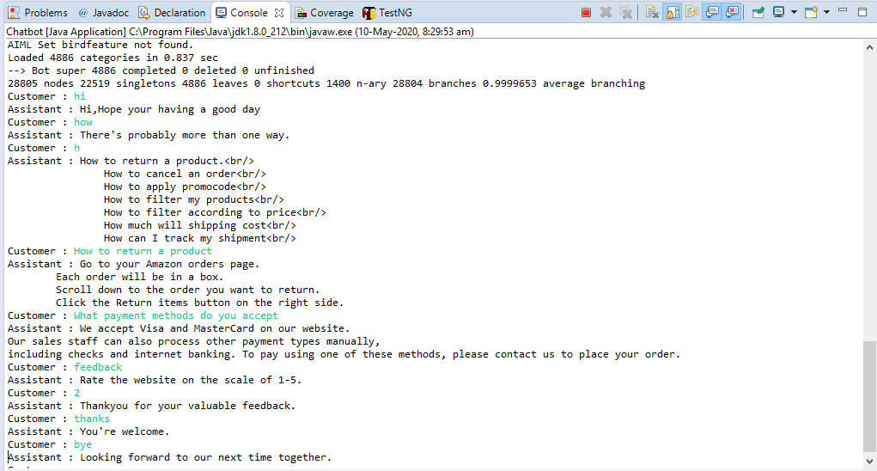

**Pandorabot**

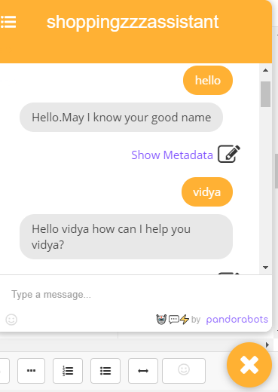

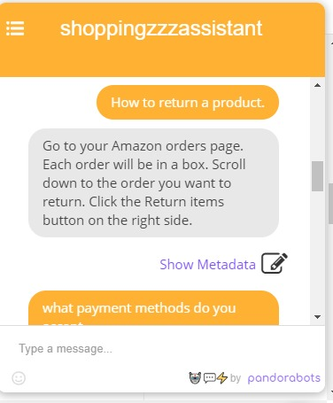

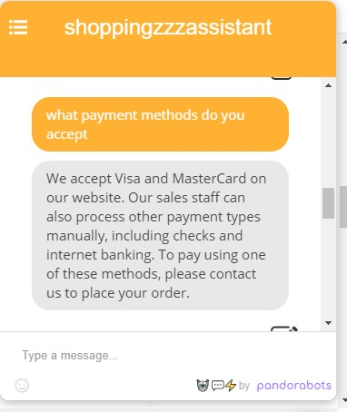

**PERT CHART**

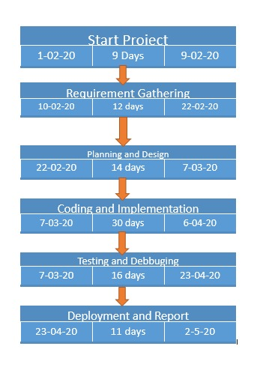

**REFERENCES**

[1]”Yotpo”,[online],Available:https://www.yotpo.com/blog/shopping-bots/.

[2]”ClickZ”, [online], Available:https://www.clickz.com/chatbots-working-well/216220/

[3]M. Kowsher, F. S. Tithi, M. Ashraful Alam, M. N. Huda, M. Md Moheuddin and M. G. Rosul, "Doly: Bengali Chatbot for Bengali Education," *2019 1st International Conference on Advances in Science, Engineering and Robotics Technology (ICASERT)*, Dhaka, Bangladesh, 2019, pp. 1-6.

[4]B. R. Ranoliya, N. Raghuwanshi and S. Singh, "Chatbot for university related FAQs," *2017 International Conference on Advances in Computing, Communications and Informatics (ICACCI)*, Udupi, 2017, pp. 1525-1530.

[5]”Snaps”, [online], Available:https://www.snaps.io/blog/examples-successful-e-commerce-shopping-chatbots.

[6]”Remarkety”,[online], Available:https://www.remarkety.com/new-trend-use-chatbots-as-shopping-assistants.

[7]”The App Solutions”,[online], Available:https://theappsolutions.com/blog/how-to/chatbots-for-ecommerce/.

[8]”A Better Lemonade Stand”,[online], Available:https://www.abetterlemonadestand.com/ecommerce-chatbots/.

[9]”EQUI ITEXT”,[online], Available:https://equiitext.com/three-features-your-shopping-assistant-chatbot-needs-to-succeed/

[10]”RETAILDIVE”,[online] Available:https://www.retaildive.com/ex/mobilecommercedaily/hm-sephora-nab-early-entry-into-kiks-fashion-bot-shop.

[11]”UX Collective”,[online], Available:https://uxdesign.cc/design-a-chatbot-for-shopping-on-amazon-df5143dda69c.